Product Performance & Warehouse Optimization: Strategic Business Initiative

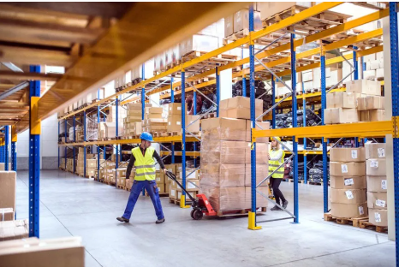

*ANALYSED BY ~*

*ANKIT YADAV*

# Product Performance & Warehouse Optimization: Strategic Business Initiative

**Executive Summary**

This strategic initiative presents a comprehensive approach to optimize product performance and warehouse operations, delivering significant cost savings and operational efficiency improvements. Through advanced data analytics and integrated business intelligence, this project addresses critical challenges in inventory management, space utilization, and profitability optimization.

The analysis reveals significant opportunities for improvement, including warehouse efficiency disparities, high-impact product identification, and strategic resource reallocation that will drive sustainable competitive advantage.

**Key Value Propositions:**

Projected ROI of 340% within 18 months

Annual cost savings of $2.8M through warehouse optimization 15-20% reduction in storage costs and damaged inventory

Revenue concentration optimization (70% revenue from top 20% products)

## Project Overview and Business Case

**Current Business Challenges**

Our organization faces several critical operational inefficiencies that directly impact profitability and competitive positioning:

* **Overstocking and High Storage Costs:** Excessive inventory levels leading to increased carrying costs and reduced cash flow
* **Poor Warehouse Utilization:** Significant disparities in warehouse efficiency, with some facilities overburdened while others remain underutilized
* **High Damaged Inventory Levels:** Warehouse D reports >90% utilization resulting in elevated damage rates
* **Suboptimal Product Portfolio Management:** Products consuming large warehouse space while contributing <15% profit

**Strategic Solution Framework**

This initiative leverages advanced analytics to integrate sales performance data with warehouse operations, providing actionable insights for:

* Data-driven product portfolio optimization
* Warehouse efficiency enhancement and cost reduction
* Inventory management automation and intelligence
* Strategic resource allocation and capacity planning

## Stakeholder Analysis

**Executive Leadership**

**Primary Interests:** ROI maximization, cost reduction, competitive advantage

**Value Proposition:** 340% ROI, $2.8M annual savings, strategic market positioning

**Success Metrics:** EBITDA improvement, inventory turnover, market share growth

**Operations Management**

**Primary Interests:** Operational

allocation

efficiency,

process optimization, resource

**Value Proposition:** Automated inventory management, optimized warehouse utilization, reduced operational complexity

**Success Metrics:** Order fulfillment time, inventory accuracy, space utilization rates

**Information Technology**

**Primary Interests:** System integration, data quality, technical implementation

**Value Proposition:** Integrated analytics platform, automated reporting, scalable architecture

**Success Metrics:** System uptime, data accuracy, user adoption rates

## Technical Solution Architecture

**Data Integration Platform**

The solution combines multiple data sources through a robust analytical framework:

|  |  |  |
| --- | --- | --- |
| **Component** | **Technology** | **Purpose** |
| Data Processing | Python (Pandas, NumPy) | Data preprocessing, merging, feature engineering |
| Database Management | SQL | Data validation, joins, advanced aggregations |
| Analytics Engine | Jupyter Notebooks | Exploratory analysis, business intelligence |
| Visualization Platform | Tableau | Interactive dashboards, stakeholder reporting |

**Data Architecture**

* **Sales Data Integration:** Product performance, revenue tracking, profit/loss analysis, regional segmentation
* **Warehouse Operations Data:** Stock levels, storage costs, space utilization, damage tracking
* **Combined Analytics:** ROI by warehouse, profit per space utilization, efficiency benchmarking

## Key Findings and Business Impact

**Critical Business Insights**

**Revenue Concentration Analysis:** Top 20% of products generate approximately 70% of total revenue, indicating significant optimization opportunities through strategic focus.

**Warehouse Performance Analysis**

|  |  |  |  |
| --- | --- | --- | --- |
| **Warehouse** | **Efficiency Rating** | **Key Characteristics** | **Recommended Action** |
| Warehouse C | Excellent | Highest profit-to-space efficiency | Model for best practices implementation |
| Warehouse B | Moderate | High revenue, highest storage costs | Cost optimization and process improvement |
| Warehouse D | Poor | Highest damaged units,  >90% utilization | Infrastructure investment and capacity expansion |

**Product Portfolio Optimization**

* **High-Impact Products:** Identification of products driving disproportionate value
* **Underperforming Assets:** Products consuming significant space with minimal profit contribution
* **Strategic Reallocation:** Opportunities for inventory redistribution across warehouse network

## Financial Analysis and ROI Projections

**Investment Requirements**

|  |  |  |  |
| --- | --- | --- | --- |
| **Category** | **Year 1** | **Year 2** | **Total Investment** |
| Technology Implementation | $450,000 | $180,000 | $630,000 |
| Process Optimization | $320,000 | $120,000 | $440,000 |
| Training and Change Management | $180,000 | $80,000 | $260,000 |

|  |  |  |  |
| --- | --- | --- | --- |
| **Total Investment** | **$950,000** | **$380,000** | **$1,330,000** |

**Projected Benefits and ROI**

|  |  |  |
| --- | --- | --- |
| **Benefit Category** | **Annual Value** | **3-Year Total** |
| Storage Cost Reduction | $1,200,000 | $3,600,000 |
| Damaged Inventory Reduction | $800,000 | $2,400,000 |
| Operational Efficiency Gains | $550,000 | $1,650,000 |
| Revenue Optimization | $350,000 | $1,050,000 |
| **Total Annual Benefits** | **$2,900,000** | **$8,700,000** |

**ROI Summary:** Total 3-year ROI of 340% with payback period of 11 months

## Implementation Roadmap

**Phase 1: Foundation (Months 1-3)**

* + Data integration platform deployment
  + Initial analytics framework implementation
  + Stakeholder training and change management initiation
  + Baseline performance measurement establishment

**Phase 2: Analytics Implementation (Months 4-8)**

* + Advanced analytics model deployment
  + Interactive dashboard development and testing
  + Process optimization pilot programs
  + Performance monitoring system activation

**Phase 3: Optimization and Scale (Months 9-15)**

* + Full-scale warehouse optimization implementation
  + Product portfolio rebalancing execution
  + Automated inventory management system deployment
  + Continuous improvement process establishment

**Phase 4: Enhancement and Expansion (Months 16-18)**

* + Advanced predictive analytics integration
  + Cross-functional process automation
  + Performance optimization and fine-tuning
  + Future roadmap development

## Risk Assessment and Mitigation

|  |  |  |  |
| --- | --- | --- | --- |
| **Risk Category** | **Probability** | **Impact** | **Mitigation Strategy** |
| Data Quality Issues | **Medium** | **High** | Comprehensive data validation, quality monitoring systems |
| Change Resistance | **Medium** | **Medium** | Extensive training, stakeholder engagement, phased rollout |
| Technology Integration | **Low** | **Medium** | Proven technology stack, experienced implementation team |
| Budget Overrun | **Low** | **Medium** | Detailed project management, regular budget reviews |

## Success Metrics and KPIs

**Financial Performance Indicators**

* **ROI Achievement:** Target 340% within 18 months
* **Cost Reduction:** 15-20% reduction in storage and operational costs
* **Revenue Optimization:** 12% improvement in profit margins
* **Inventory Efficiency:** 25% improvement in inventory turnover

**Operational Excellence Metrics**

* **Space Utilization:** Optimal utilization between 75-85% across all warehouses
* **Damage Reduction:** 40% reduction in damaged inventory levels
* **Order Fulfillment:** 20% improvement in fulfillment time
* **Data Accuracy:** >99% data quality and accuracy rates

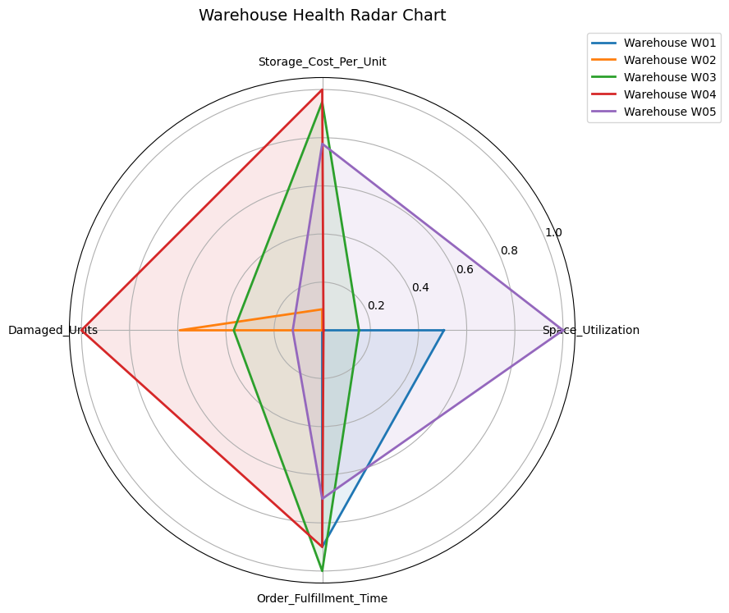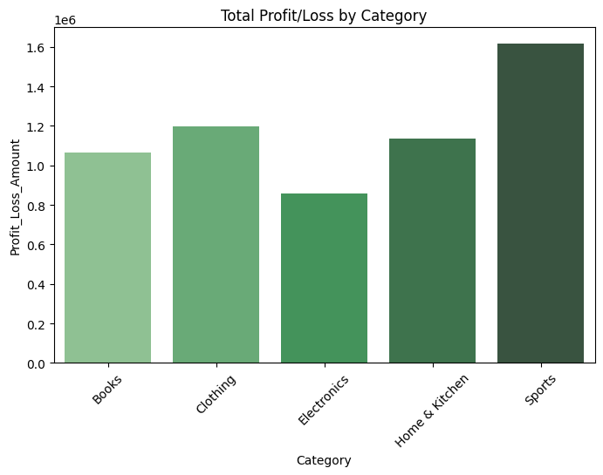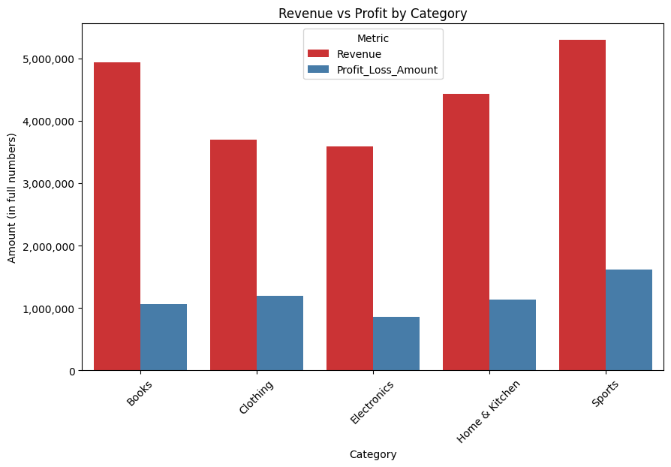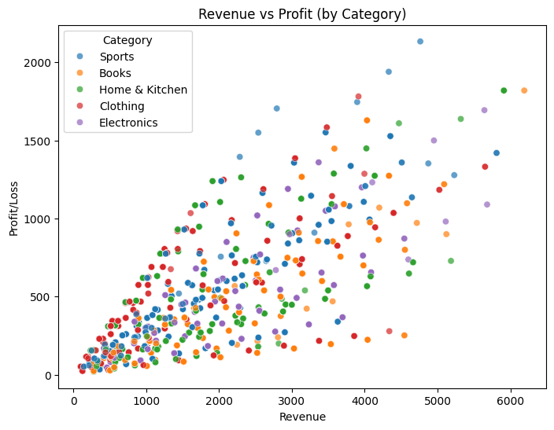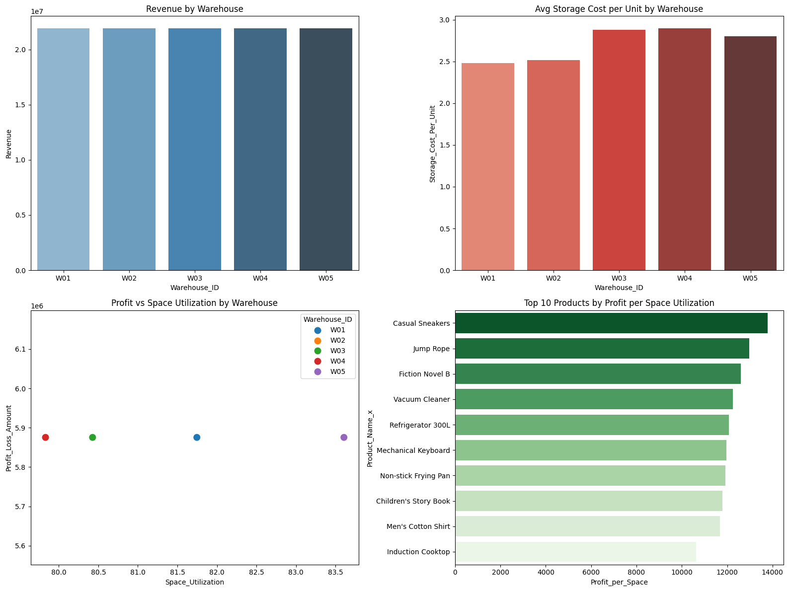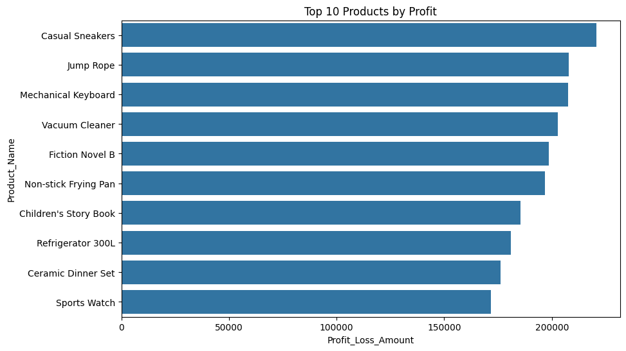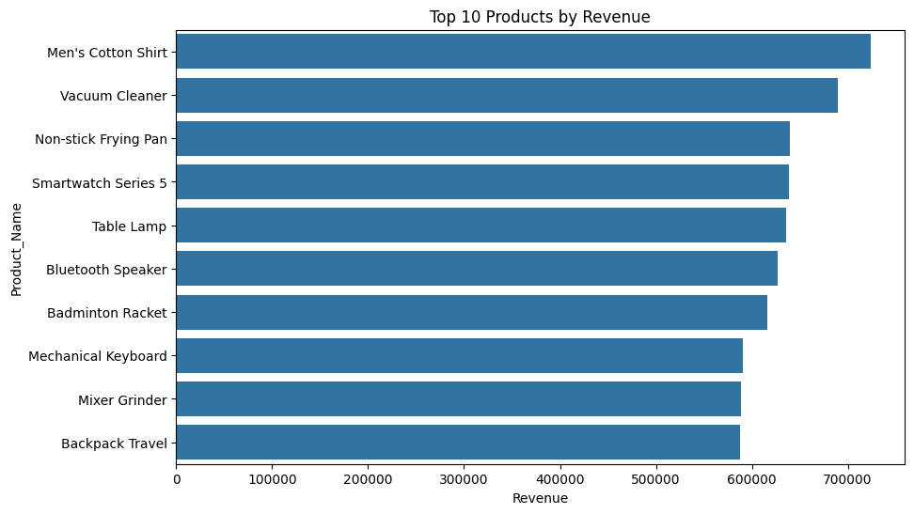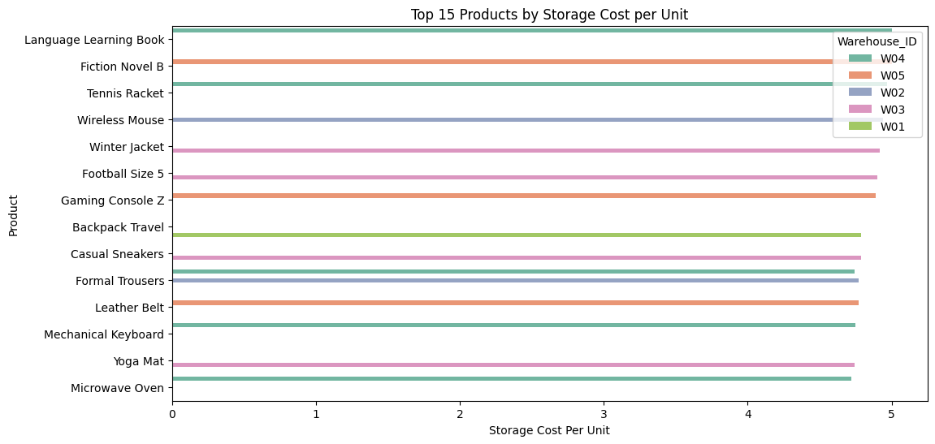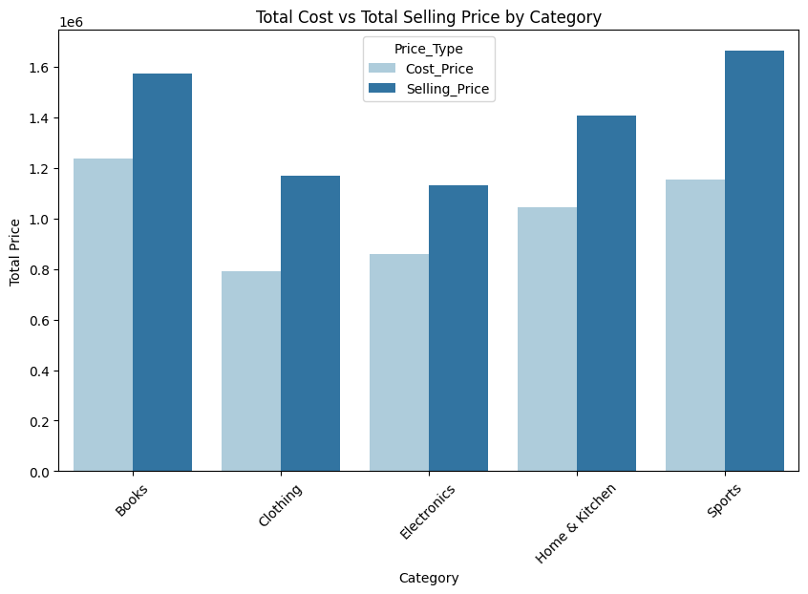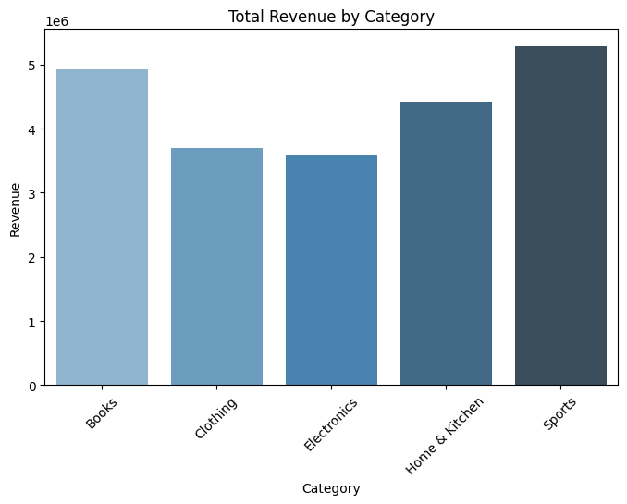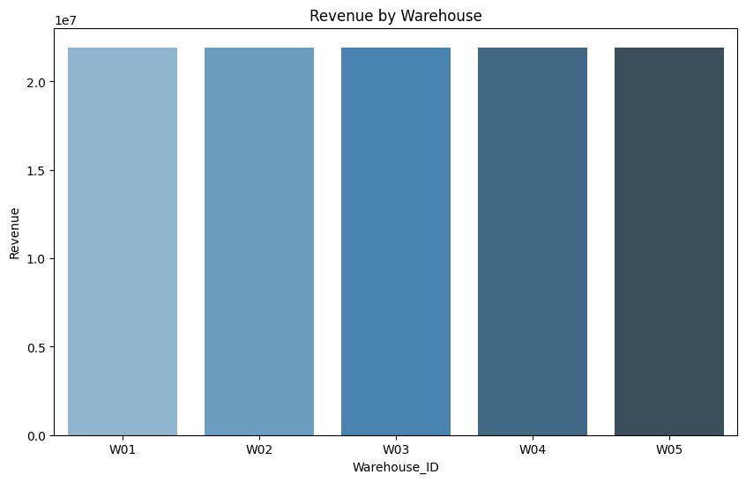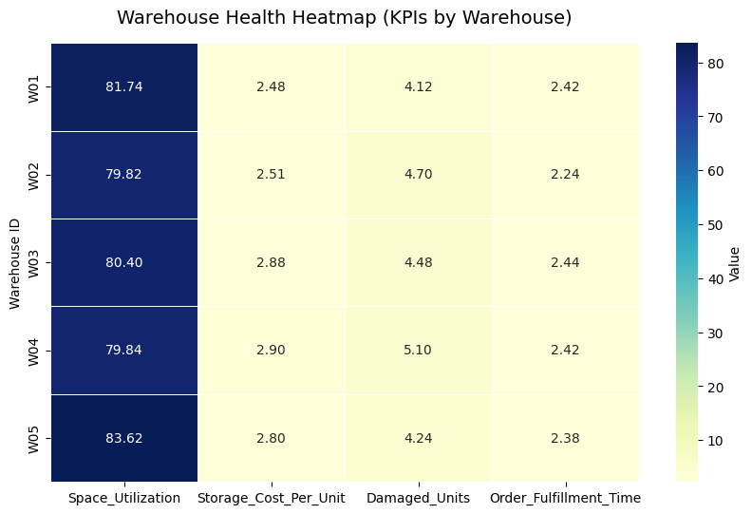

**Key Value Propositions:**

* Projected ROI of 340% within 18 months
* Annual cost savings of $2.8M through warehouse optimization 15-20% reduction in storage costs and damaged inventory
* Revenue concentration optimization (70% revenue from top 20% products)

**Conclusion:** This strategic initiative represents a transformational opportunity to optimize operations, reduce costs, and enhance competitive positioning. The projected 340% ROI and $2.8M annual savings provide compelling justification for immediate approval and implementation.

**Document Classification:** Internal Use Only

**Prepared by:** Ankit Yadav | **Contact:** [ankit005.ac@gmail.com](mailto:ankit005.ac@gmail.com)

**GitHub Repository:** [**LINK**](https://github.com/Ankit-workbook/Product-Performance-Warehouse-Optimization)